**COMP 3133 – Full Stack Development – Lab 1**

* ES6 Practice Exercises

**Developer Note:**

* Try to solve the problems without using search engines or stack overflow for the solutions.

**Exercise 1:**

* Using ES6 syntax, write a function that will get the difference between a given number and 13, if the number is greater than 13 return double the absolute difference



Output:

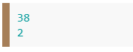

**Exercise 2:**

* Rewrite the following code block using ES6 syntax, *ie. const, let, arrow function, template literals and for..of*

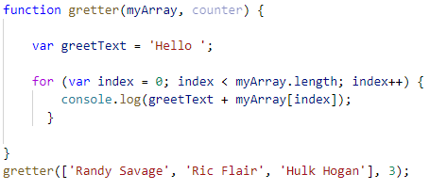

**Exercise 3:**

* Using **array.proto.map** create function to use the capitalize method in Exercise 2 to upper case the first character of each Color in the following array..

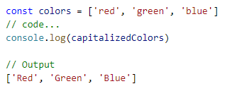

***Array.proto.map Reference***  
 <https://developer.mozilla.org/en-US/docs/Web/JavaScript/Reference/Global_Objects/Array/map>

**Exercise 4:**

* Using **array.proto.filter** create a function that will filter out all the values of the array that are less than twenty.

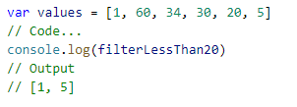  
  
 ***Array.proto.filter Reference***  
 <https://developer.mozilla.org/en-US/docs/Web/JavaScript/Reference/Global_Objects/Array/filter>

**Challenge:**

* Using **array.proto.reduce** create calculate the sum and product of a given array.

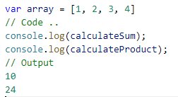

***Array.proto.reduce Reference***

<https://developer.mozilla.org/en-US/docs/Web/JavaScript/Reference/Global_Objects/Array/Reduce>